1.

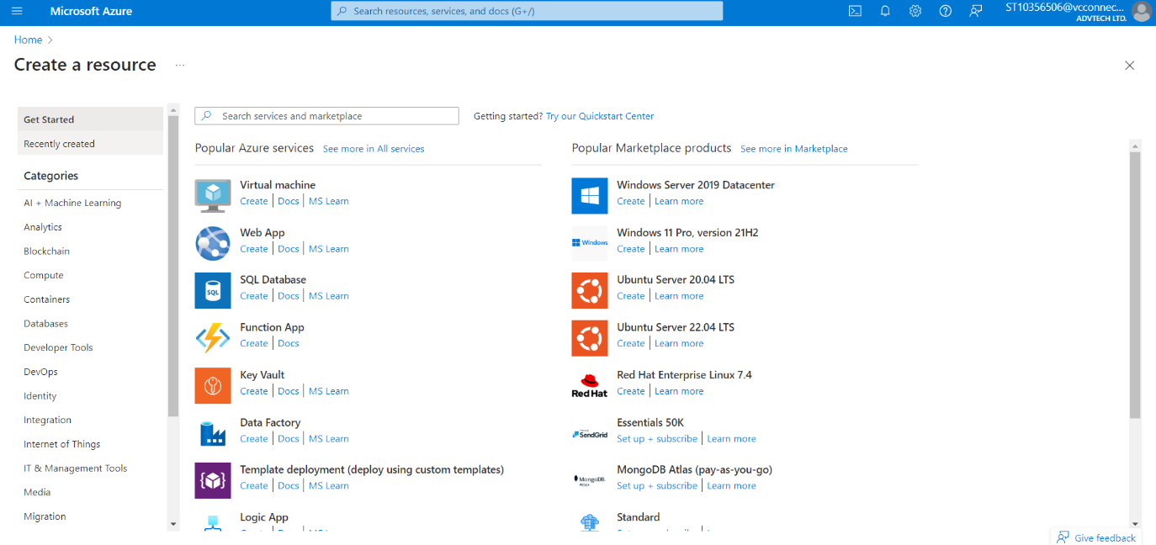select locally-redundant backup storage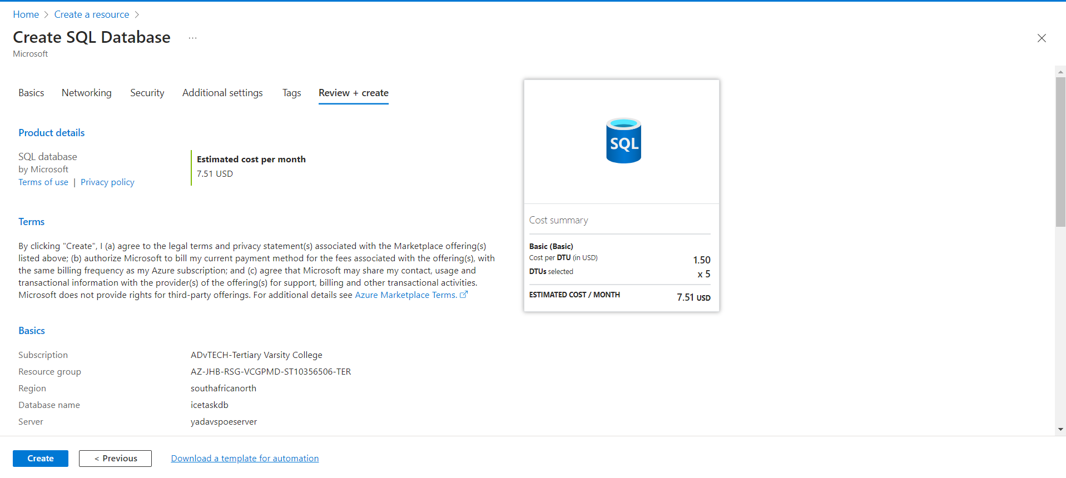review and create

2.

- create sql database in azure

- configure firewall settings to allow selected networks to access the database from azure

- select sql databases under settings

- login to the database using credentials created when creating the database

- copy your ssms database and paste it into the azure query editor

3.

- within the appsettings.json, edit the connection string to match the database connection string.

- build the project (ctrl+b)

- when the build succeeds, click tools>manage NuGet packages>package manager console

- in the package manager console, type “Add-Migration “your migration name” ”

- after you add the migration, you’ll need to implement it. To do this, type “Update-Database”

- after you update the database, a physical database will be created in ssms.